Using Putty with AWS

1. Download putty from the following URL: <http://the.earth.li/~sgtatham/putty/latest/x86/putty-0.65-installer.exe>
2. Wait for the download to finish.
3. Run the installer once the download is finished.
4. If prompted by User Account Control, click yes. 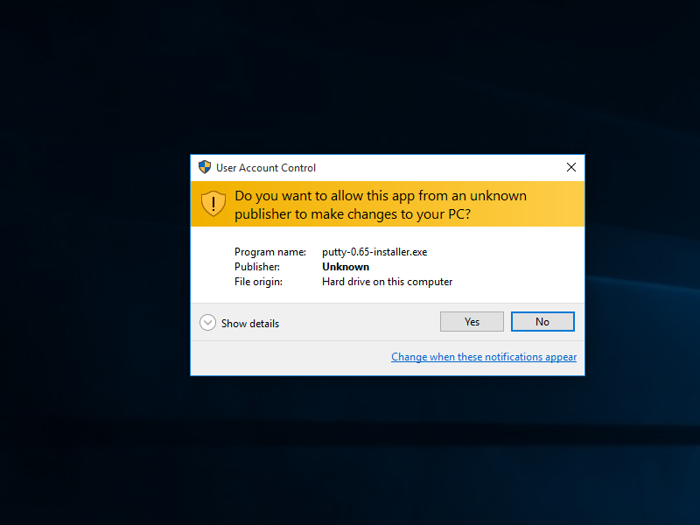
5. Click next. 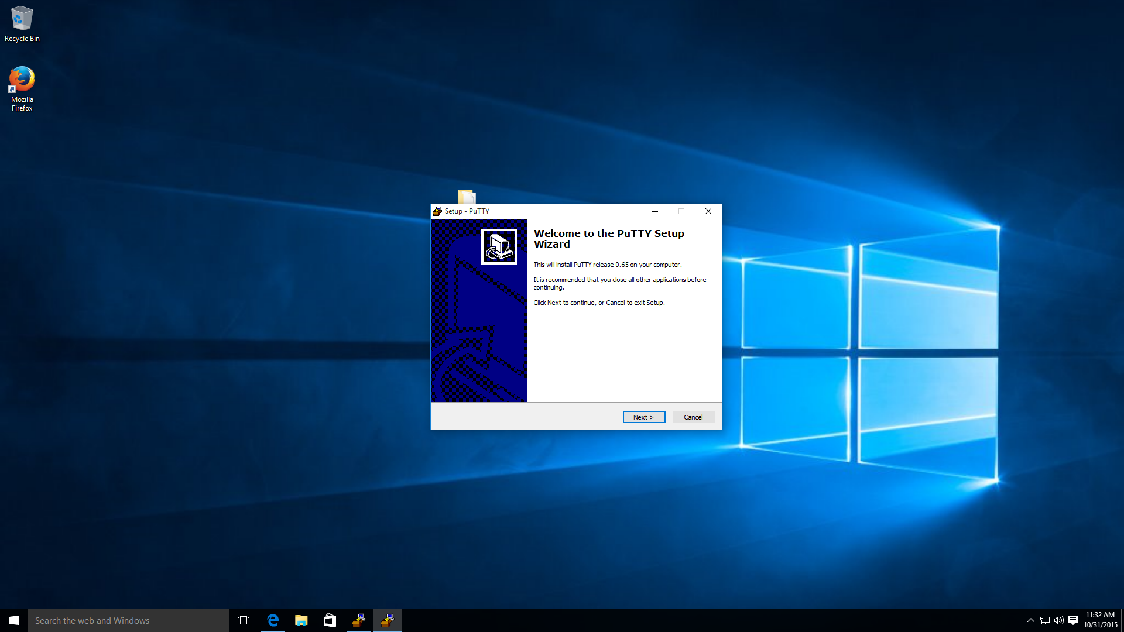
6. Keep the default settings, and click next. 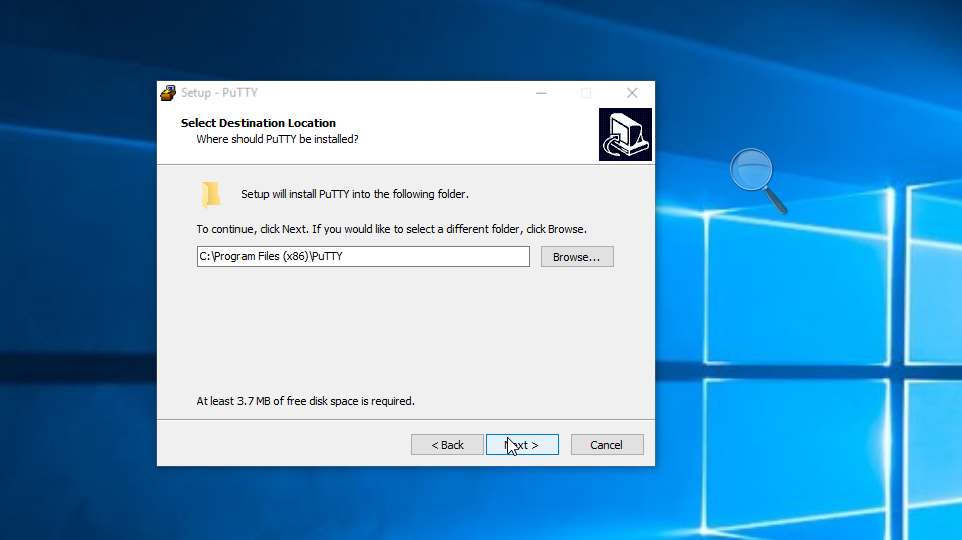
7. Let the installation finish, and click finish to end the installation. 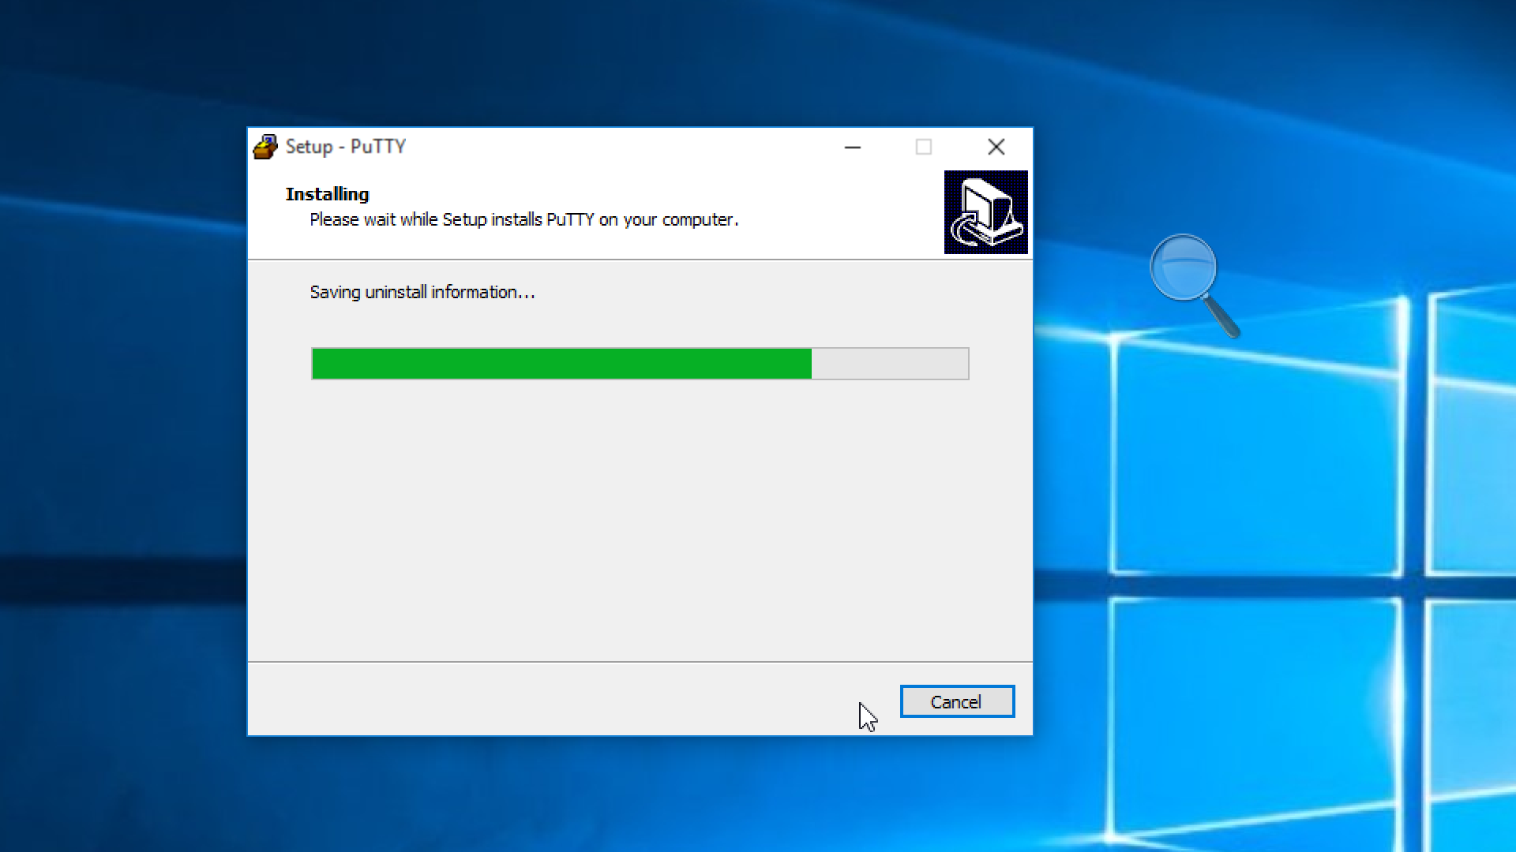
8. Log in to AWS, and click on EC2. On the navbar on the left, click on key pairs to see the below screen. Select **Create Key Pair**. 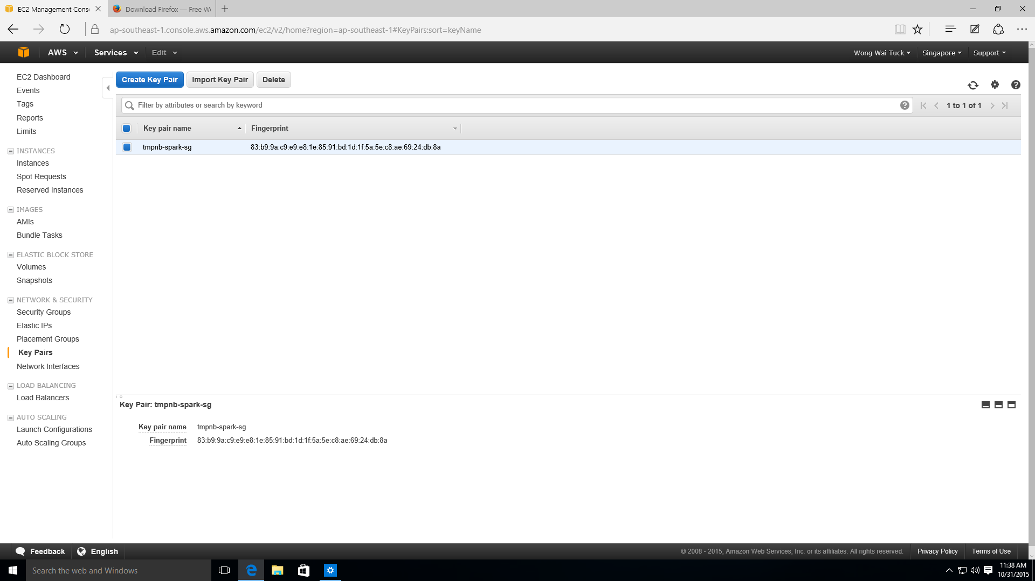
9. Give the keypair any name you want, and click create. 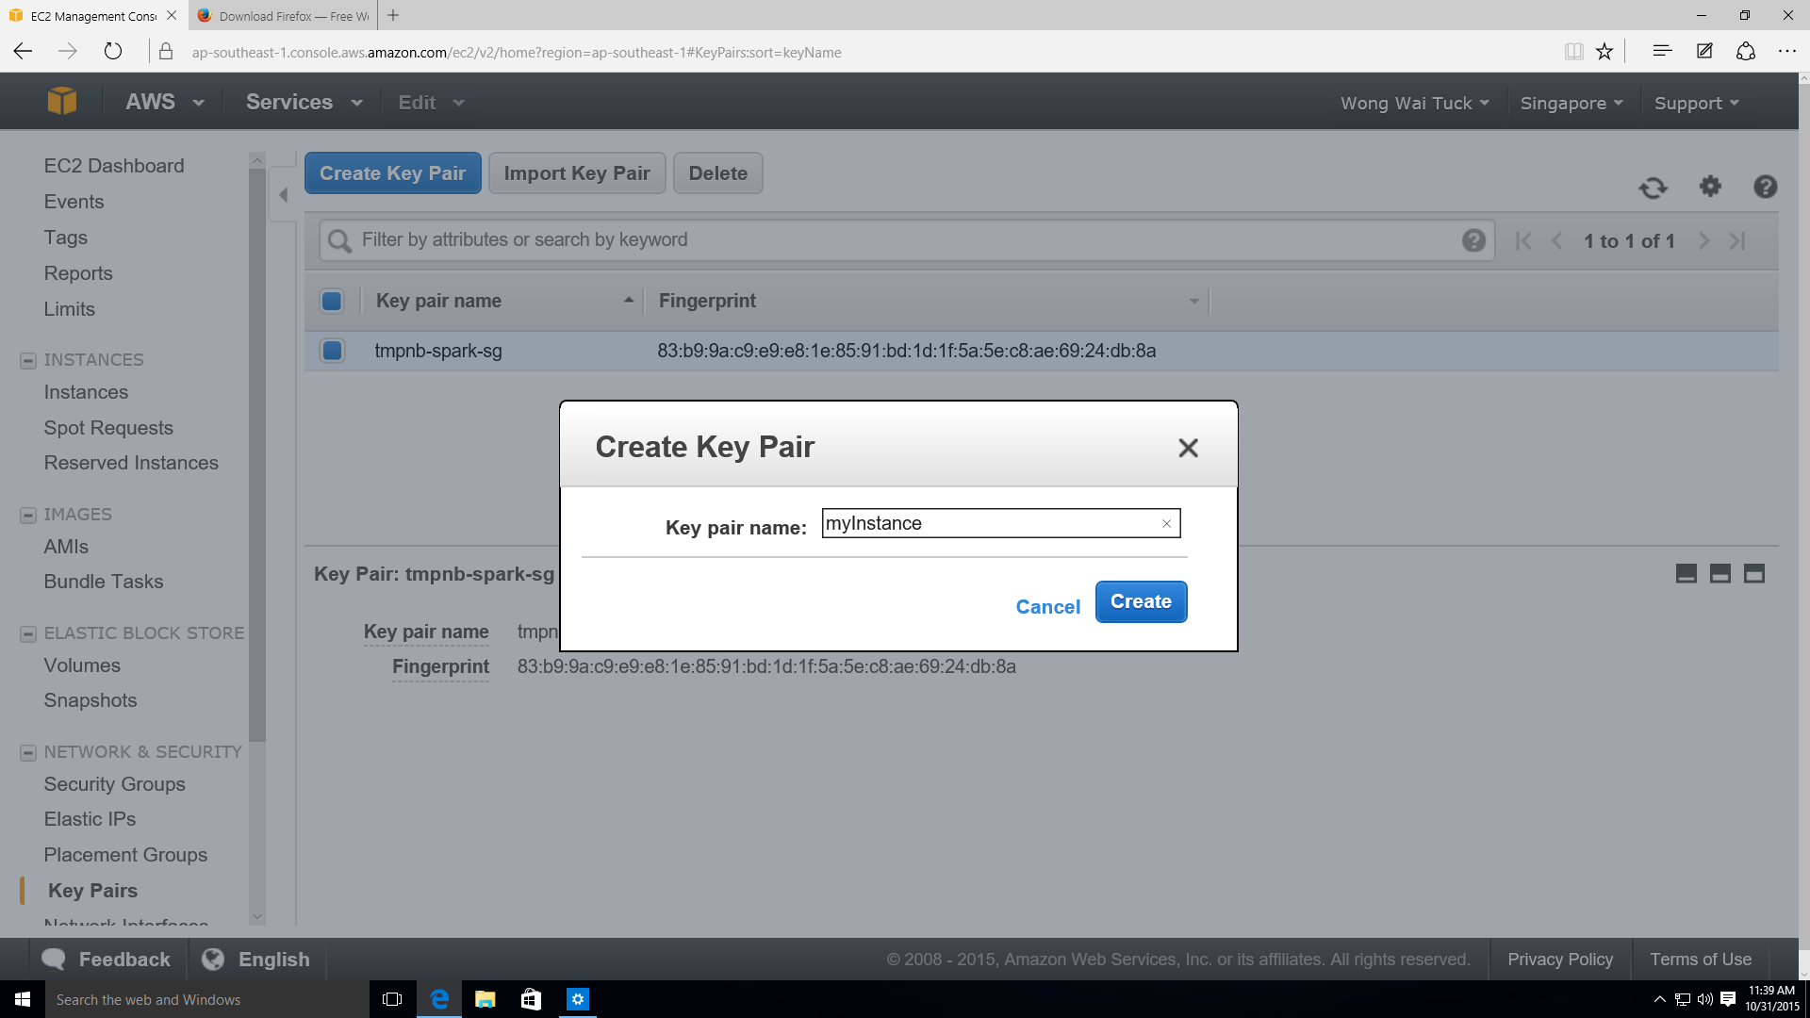
10. Your key will start downloading automatically. Take note of where it is stored! 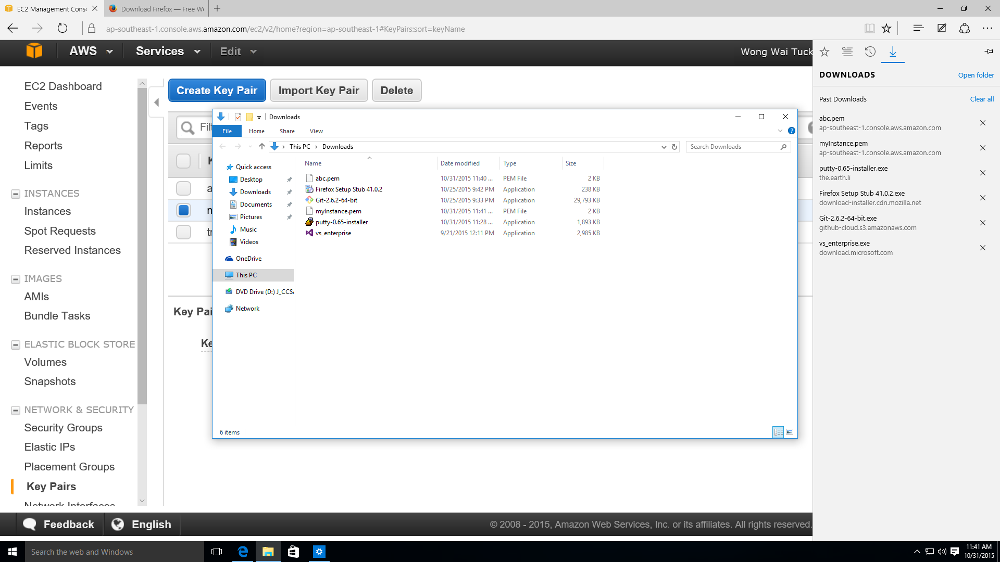
11. Now we will convert the key to something putty (the Windows SSH client) recognises. Go the start, and type puttygen. Click on the icon that appears first. 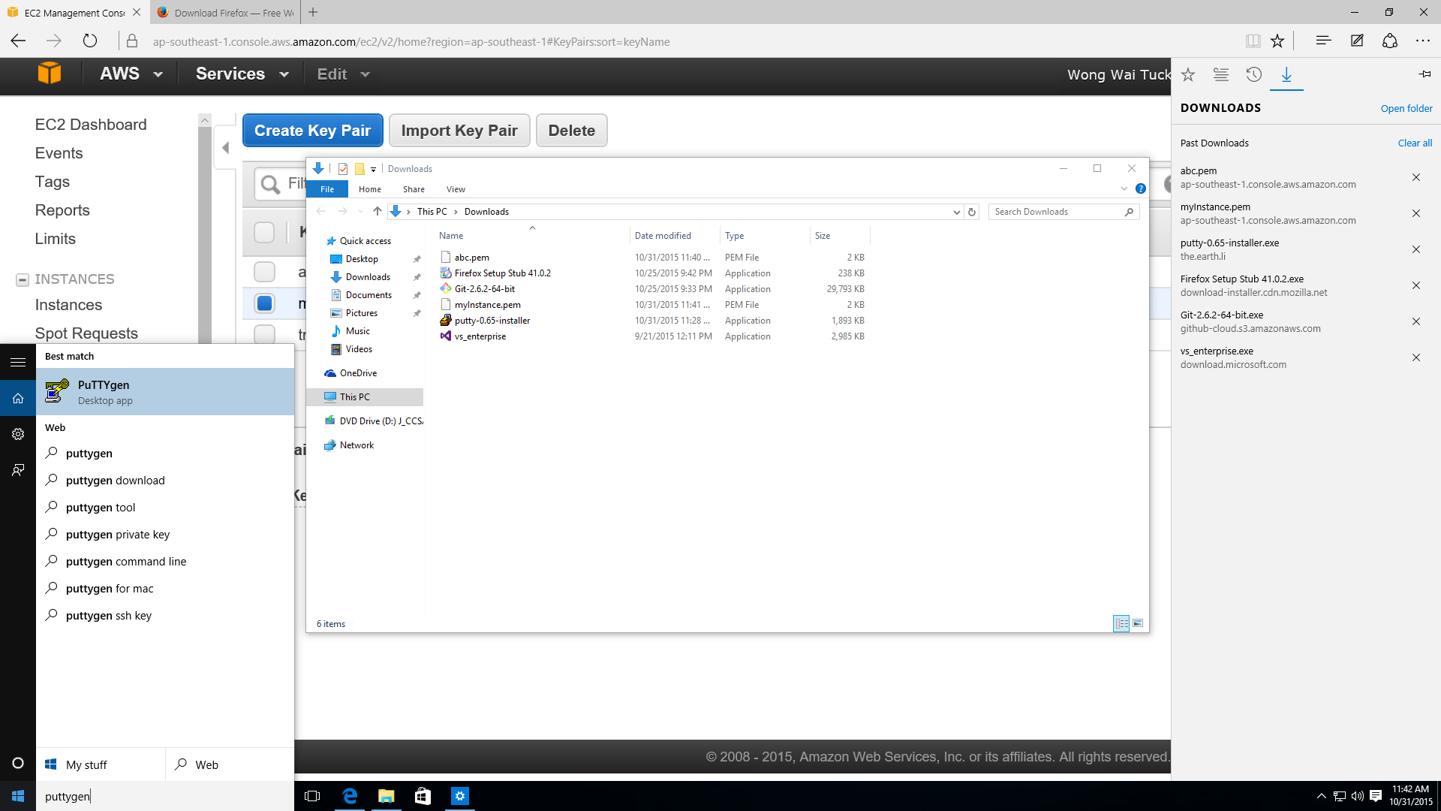
12. On the puttygen screen, press load. 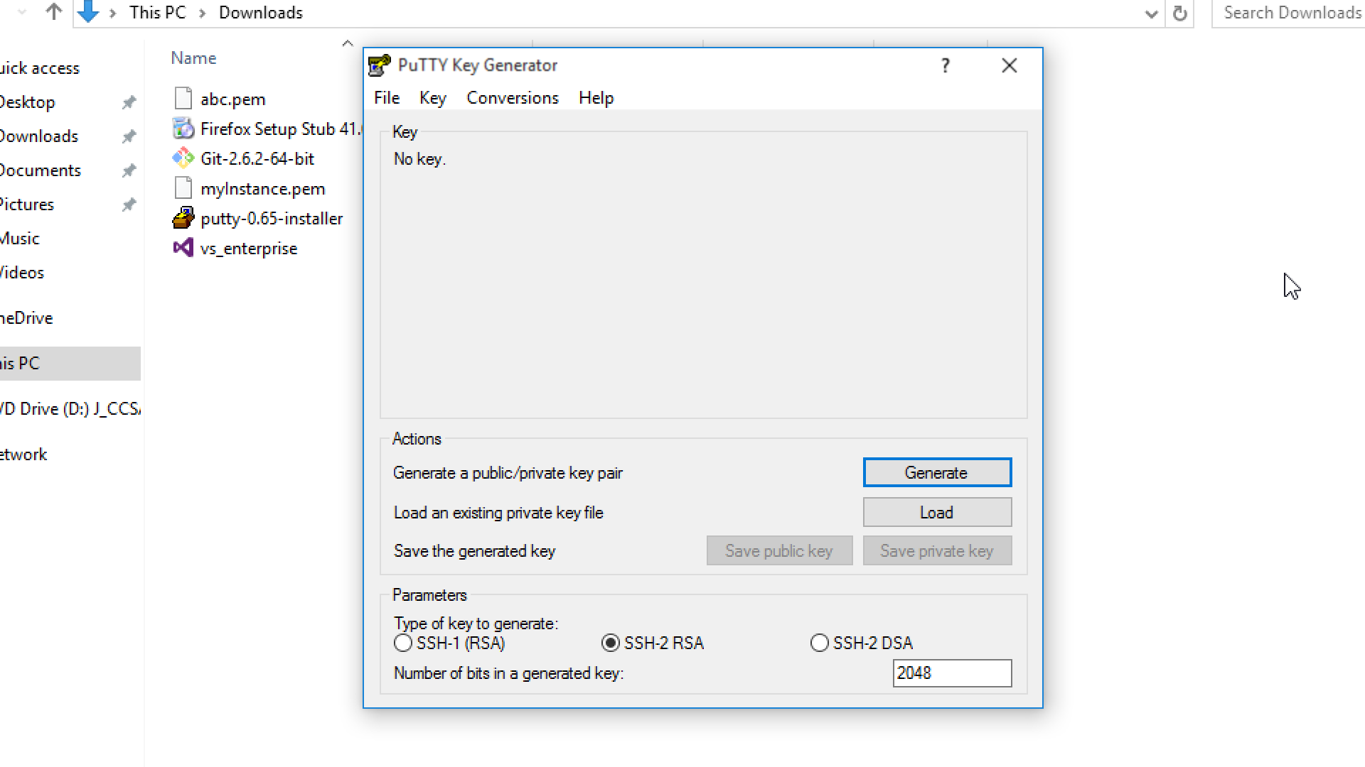
13. Load your private key that you have created on amazon. You have to click on All Files to see the private key. 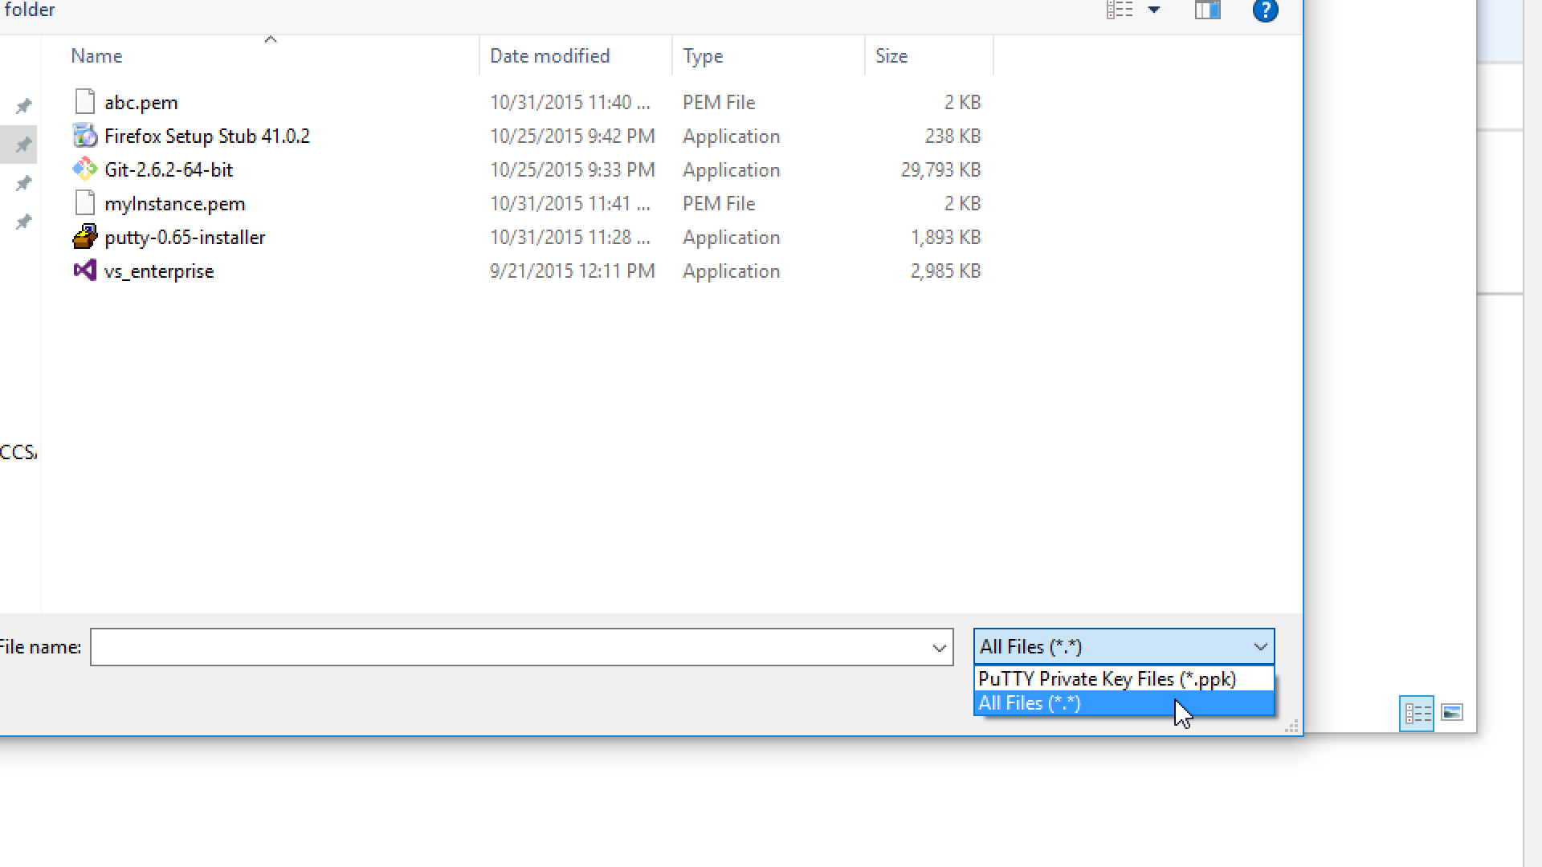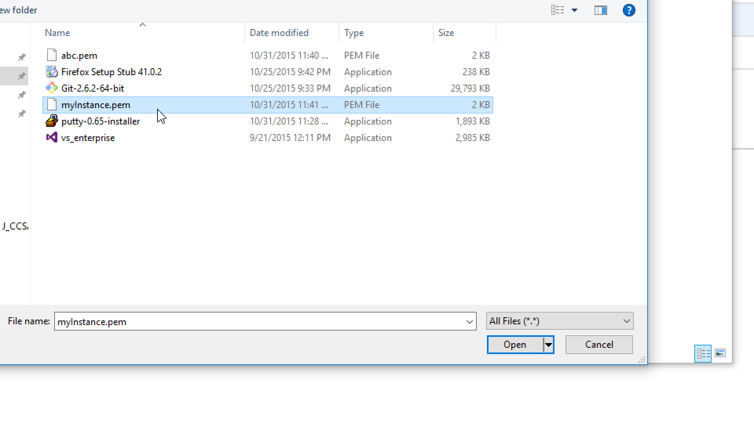
14. Now save private key. You may choose to include a passphrase to protect it if you wish to, but it is not necessary for the purposes of this tutorial. 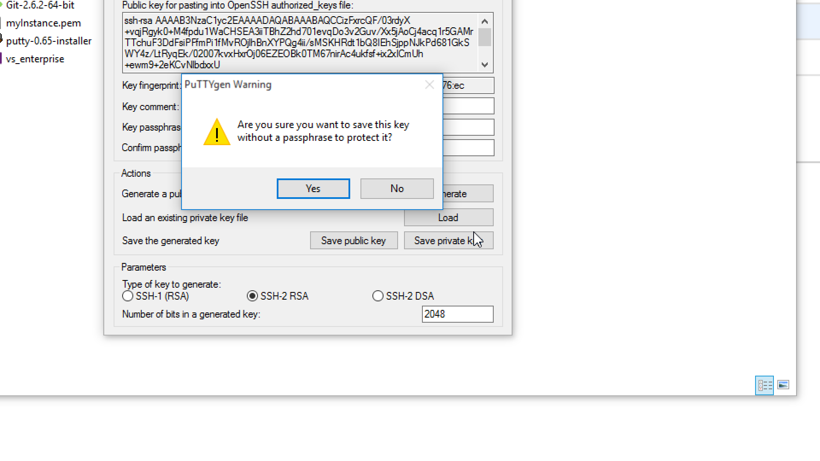
15. Save the file in whatever name you desire, and press Save. **DO NOT LOSE THIS KEY.**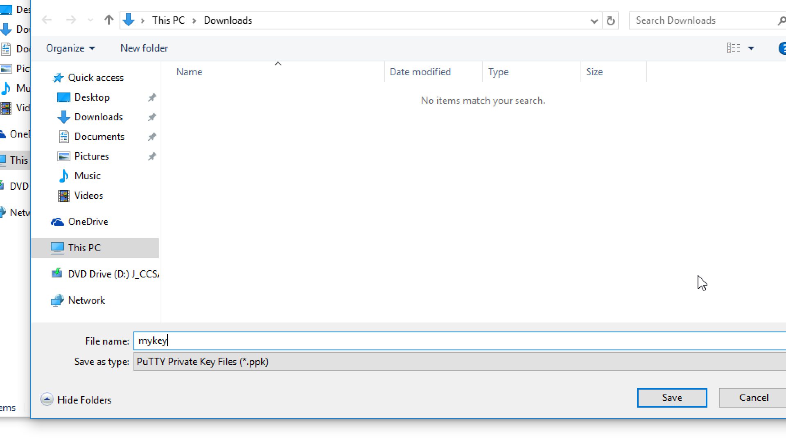
16. Now when you launch a new instance in AWS, at the last step when you press launch, please select the existing key pair you have converted before you launch your instance, as shown below: 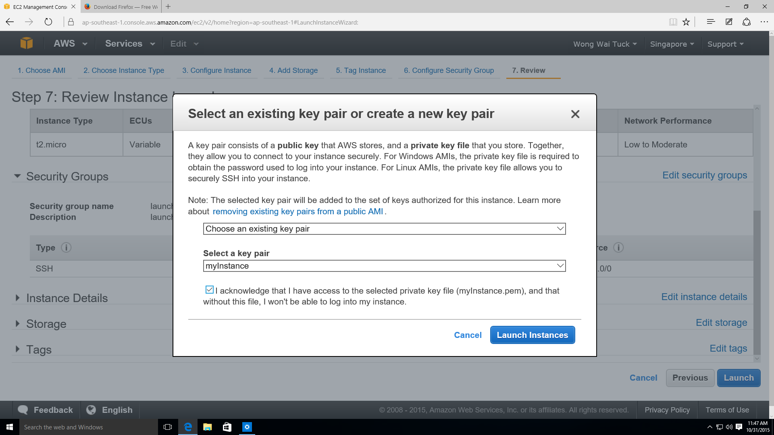
17. Now to connect to your new instance, you need to use putty. Go to the start menu and look for putty. 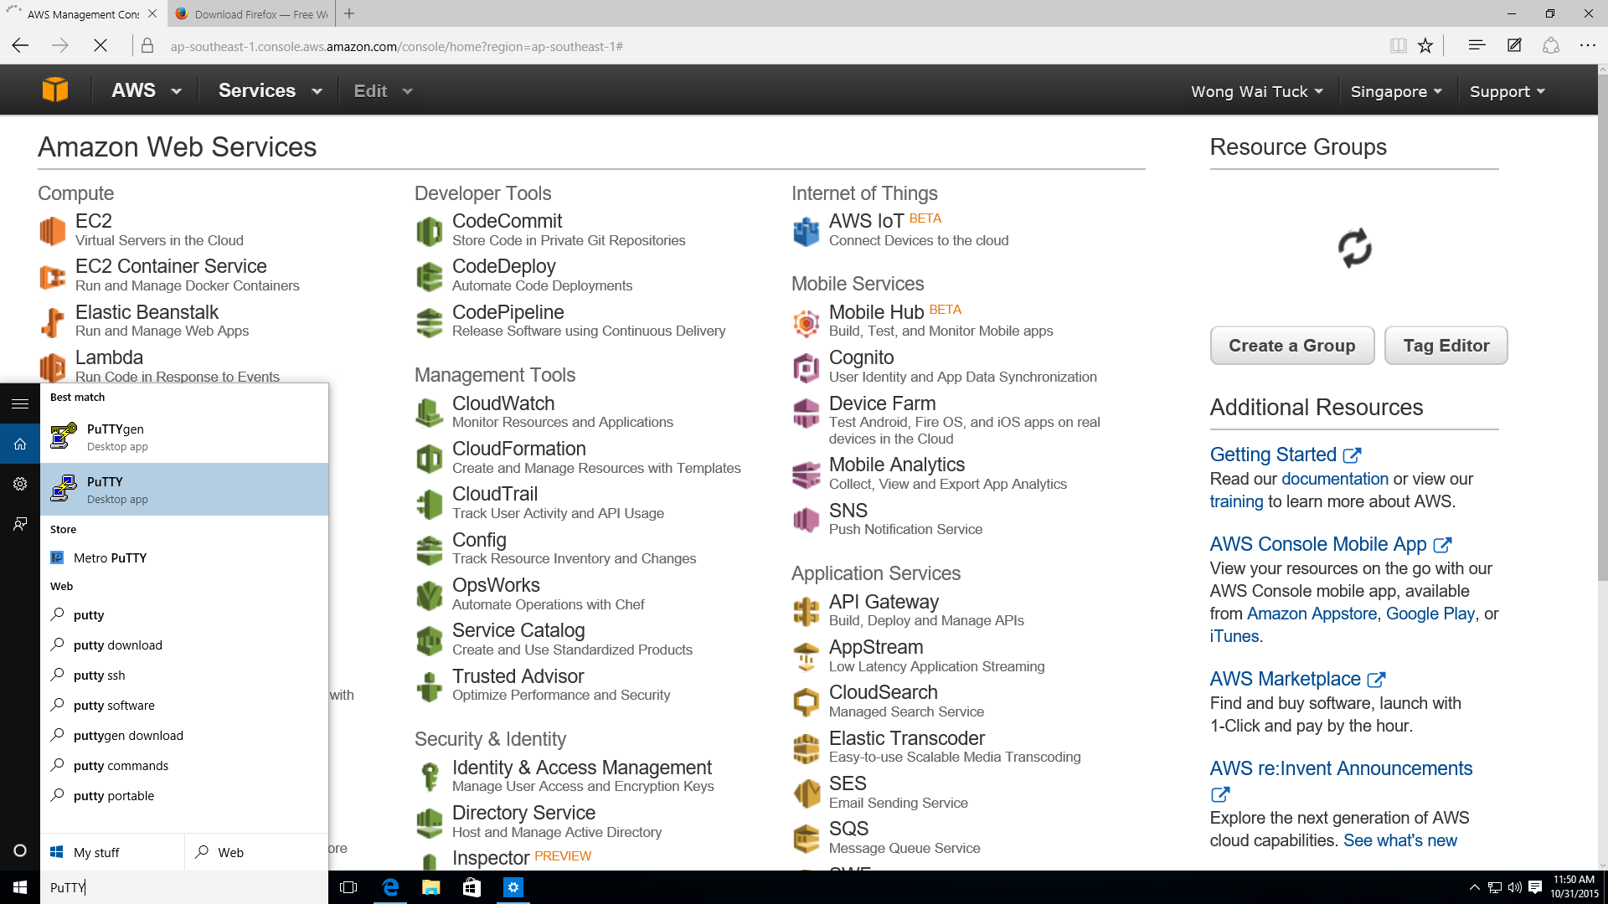
18. When you open putty, on the left navbar, go under Connection > SSH > Auth and click on Auth. You should see the following screen: 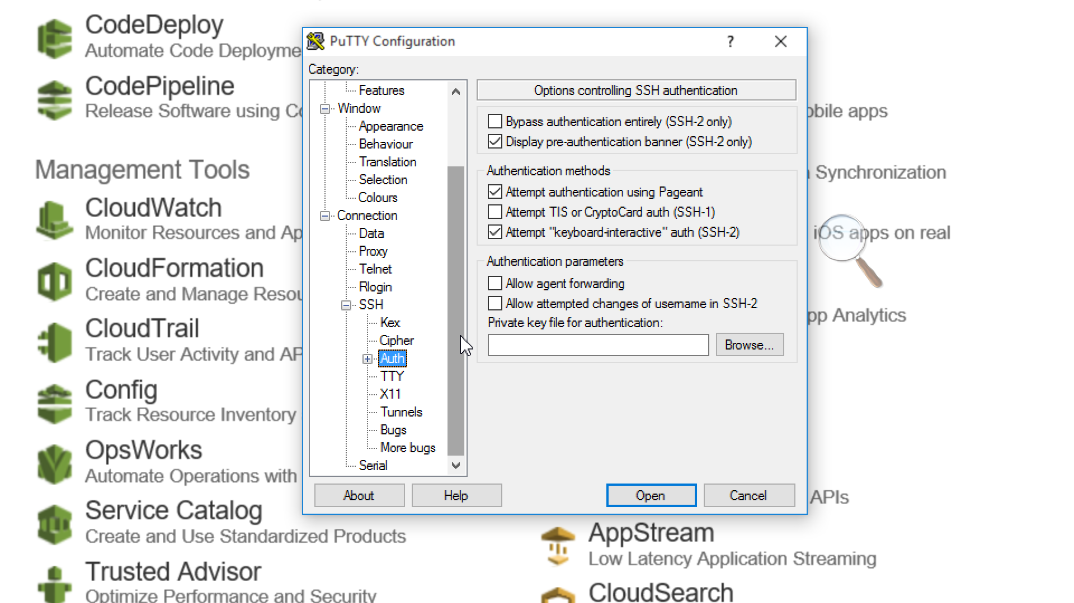
19. Browse to the key you have created in step 15), and click Open. 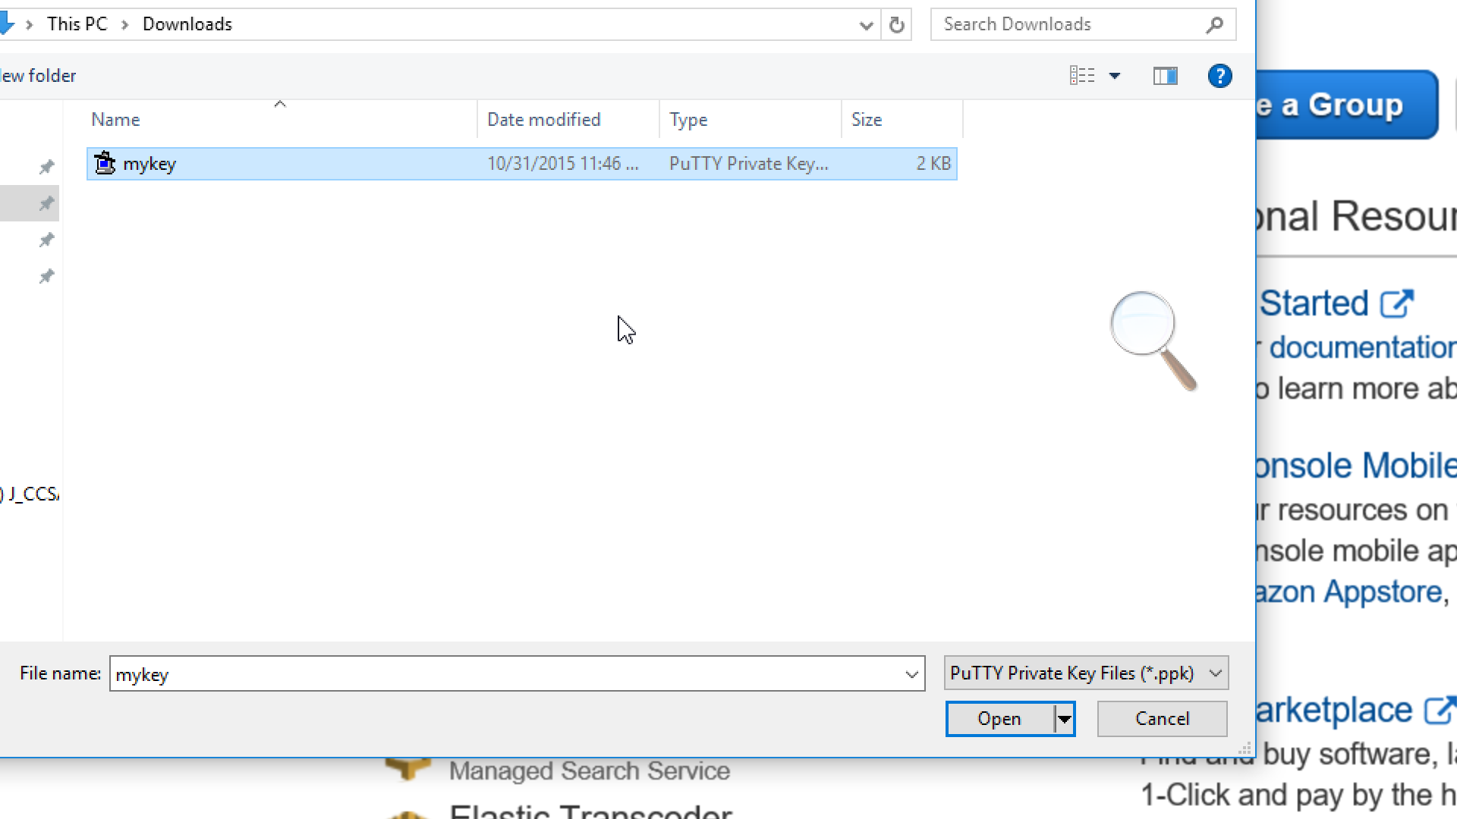
20. Scroll back to the top and click on Session. 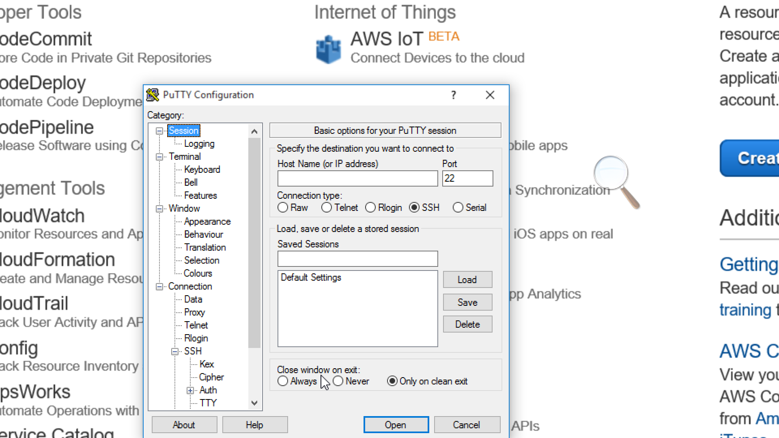
21. In your new running instance, right click and click Connect. 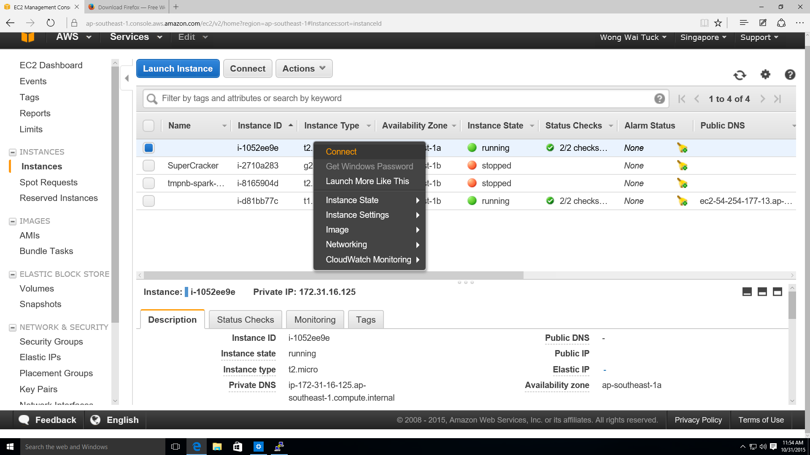
22. Copy the following line on the screen. It should be something like ec2-user@xx.xxx.xxx.xxx

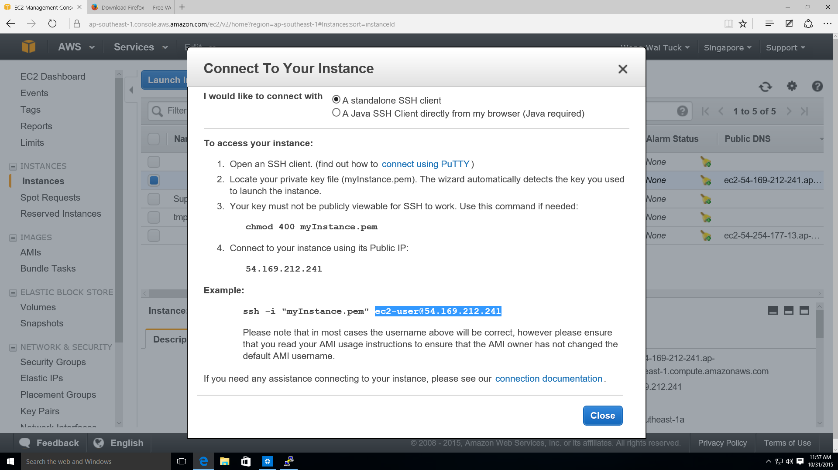

1. Go back to your putty and paste the line which you have copied into the Host Name row.
2. When prompted by Putty, click yes. 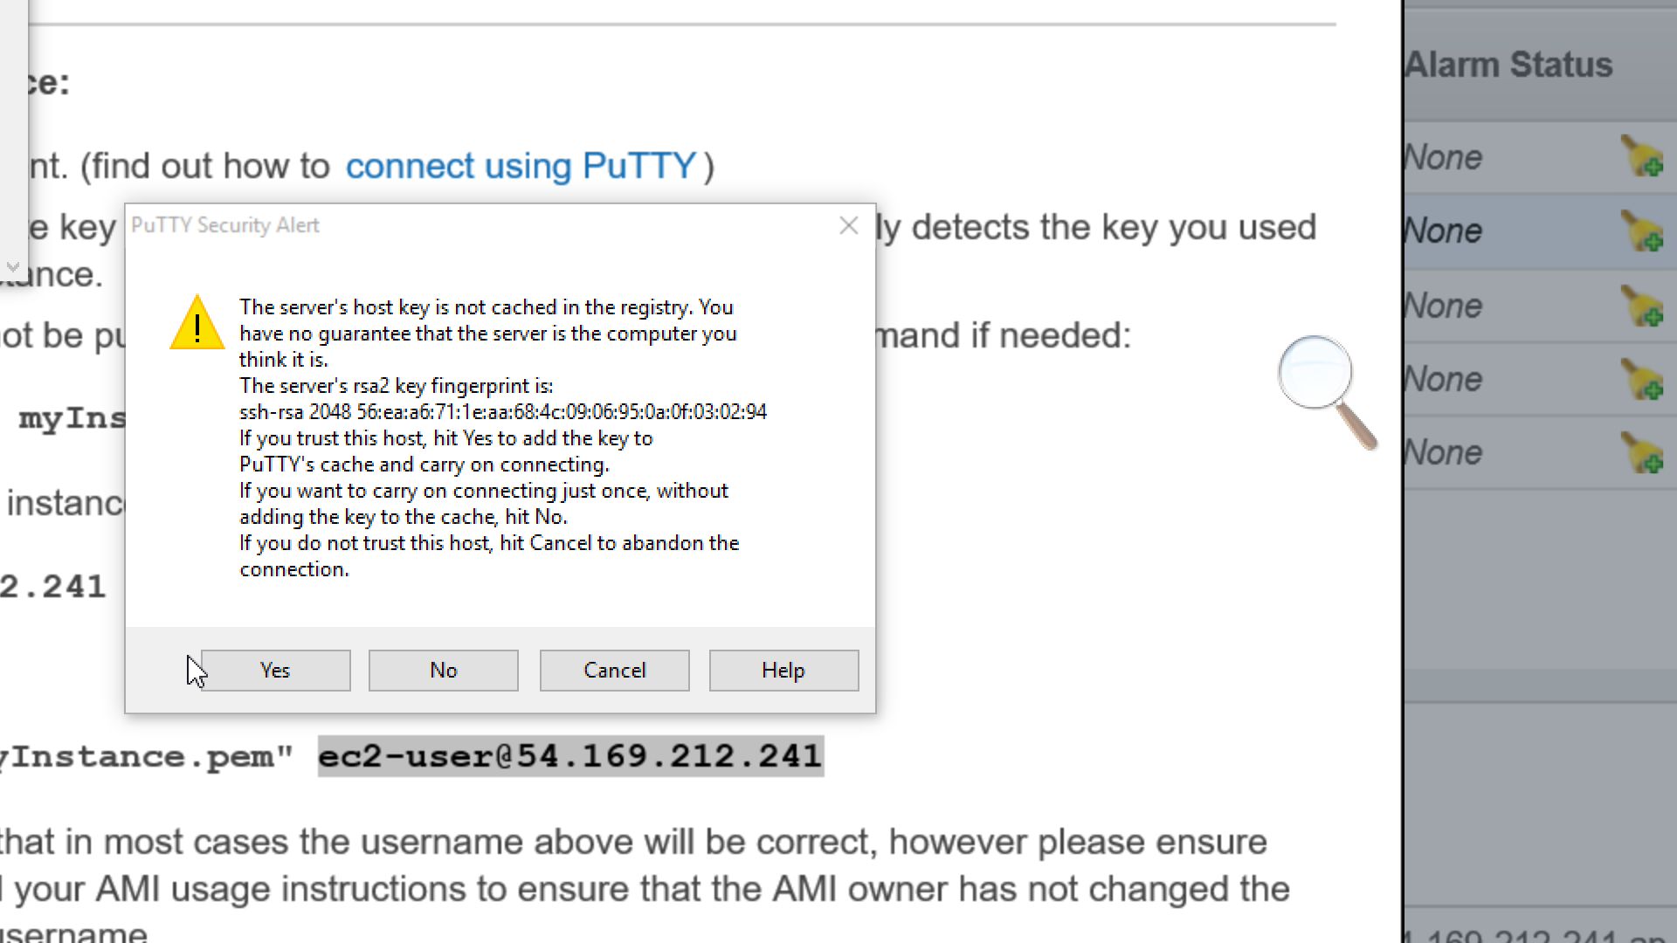
3. Congratulations, you have logged in to the AWS instance using Putty! 